Project simulated in Proteus 8

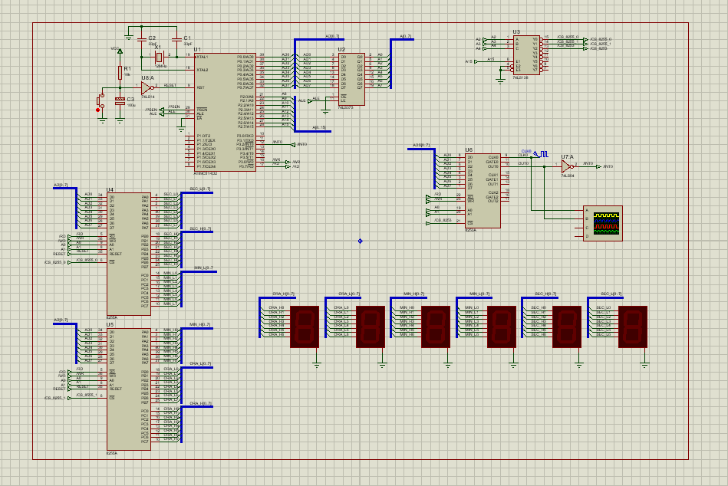

The diagram is a clockwatch made out of interruptions, the source code was written in Keil (a.51).